Contact Manager
Ideation Phase
Define the Problem Statements

Date | 16/02/2026
Team ID | SWTID-2026-4180
Project Name | Contact Manager
Maximum Marks | 2 Marks

Problem Statement
Many people find it difficult to manage and organize their contact information properly. Most of the existing applications are mainly designed for mobile phones, and they may not provide easy access when users are working on their laptops or computers. Because of this, users often struggle to quickly store, search, and retrieve contact details when needed. A simple and efficient Contact Manager system can help users store and organize their contacts easily and access them whenever required.

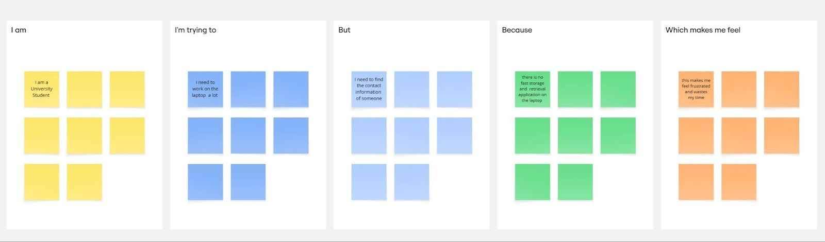

Problem Statement (PS) | I am (Customer) | I’m trying to | But | Because | Which makes me feel
PS-1 | A university student | Store and retrieve contacts on the laptop | Most platforms are only available for mobile phones | I need quick access to my contacts while i am working | Frustrated
PS-2 | A developer | Get the required contacts on laptop while working | The available applications are for mobile phone | I need a simple, visually appealing interface to store and get my contacts | Waste of time to continuously use mobile while working

